COAST Proposal Draft, Fall 2024

Savannah K. Miller

# COAST Draft Proposal, Fall 2024

## Project Description

### Background

Current research shows that there is a complexity of potential futures for marsh ecosystems, in light of expected worldwide sea level rise (Kirwan et al 2016, Callaway 2007). Marsh lands are home to a specific set of species, which are carefully adapted to the unique saline and freshwater influences that characterize a marshland (Dunson and Travis 1994; Fagherazzi, Marani, Blum 2004, pg. 12) . In addition to the unique biodiversity of salt marshes, there have been greater insights on marsh lands roles’ in dampening the impacts of atmospheric rivers and extreme weather events, offering a potential benefit to humankind to protect coastal cities and urban areas (Taylor-Burns 2024, Smolders 2015). Human activity, resource use, and urbanization of these ecosystems has left the remaining marsh ecosystems scarce and vulnerable to the predicted effects in climate when accounting for preserving species and ecosystem function (Gedan 2009). The potentiality of this future is daunting on a worldwide scale. The individual complexity of the tidal, geomorphic, and vegetative makeup of each estuary underline the importance of detailed in-field confirmation of the existing abiotic processes at play on a local scale if more mashes are to be built and restored (Ritter 2008, Thorne 2023, Moffet 2010)

Sediment is the major component in a marsh, transported through waves and tidal action suspended in the water (suspended sediment), and later contributing to surface area and composition of the marsh through disposition, and then accretion with multiple layers of sediment layering across the marsh platform (Ganju 2005, Lacy 2019). To improve marsh ecosystems, understanding the paths that sediment takes to get to the marsh are pertinent to building and retaining more successful marsh restoration projects (Fagherazzi 2013, Bloemendaal 2021, Vandenbruwaene 2011).

Vegetation also plays an important role along the marsh platform in terms of attenuating sediment to the surface, allowing for it to accrete over time (Temmerman 2005). Evidence comes from multiple models and in-field studies that have determined that vegetation is a key factor to control flow and sedimentation patterns in the marsh platform, and even assist in differences in levels of disposition on the marsh platform. Specifically in the San Francisco Estuary, It has been observed that two vegetative species work together in tandem for both accretion and disposition of sediment, respectively (Lacy 2019). Across studies, the link between vegetation structure, density, and location is complex when taking into account differences in their function in sediment accretion (Boorman 2016).

Therefore, it is crucial for vegetation growth and structure to be monitored in tandem with understanding differences in suspended sediment behavior across the marsh platform.

At the forefront of the issues of sea level rise is the marsh edge, where the start of this terrestrial ecosystem bares the brunt of tidal cycles, storm influences, and erosional impacts to the sediment bank. The marsh edge is a dynamic area of the marsh that is thought to evolve through different types throughout the lifecycle of the marsh (Moller 2002, Moller 2006). However, more information is needed to understand the dynamics of the marsh edge type in order to classify the marsh edges, and therefore make management decisions for the marsh as a whole in response to critical issues like sea level rise (Shifting Shorelines Beagle et al 2015). Our study will focus on how suspended sediment transport paths differ along different marsh edge types. Vegetation monitoring of Pickleweed (*Salicornia pacifica*) will also be completed along the marsh edge, taking measurements of the structure of the plants to correlate their accretional potential for the sediment bank.

### Graphical user interface Description automatically generatedResearch Objectives

Based on previous literature (Shifting Shorelines Beagle et al 2015), there are thought to be five marsh edge types, which are based on the geomorphological differences: scarp with bayward vegetation (SV), scarp without bayward vegetation (SN), ramp without inflection point (RNI), ramp with inflection point (RI), and beaches or rocky shoreline (B). Within the report, the “scarp without bayward vegetation” had the highest rates of retreating at the time of the report. The location of these marsh edge types can be linked to the riverine-estuary connection of the Gallinas Creek, Sonoma Creek, Petaluma River, and Napa River. These correlations in observations provide a great opportunity to confirm conditions of the adjacent marshlands to understand the variables at play within the action. Considering the key role of vegetation within this finding and past research, we have the following research objectives:

Figure 1. Marsh Edge Types (Beagle 2015)

* To better understand the sediment transport pathways along the scarp without bayward vegetation marsh edge type vs. scarp with bayward vegetation marsh edge types, through measurement of suspended sediment in the water column and accreted over the marsh over time.
* To understand the role and differences in bayward vegetation across a marsh edge (cordgrass) and within the marsh (pickleweed) in rates of sediment accretion on a marsh land platform
* To compare the validity and level of detail of in-field measurements against annual sensors for suspended sediment

### Hypotheses

Sites further eastward of the San Pablo Gyre with higher densities and canopies of pickleweed alongmarsh edge will accrete at higher rates than those edges further west with increased tidal action, and no bayward vegetation

### Methods

All measurements will be collected over 2 summer seasons, and 2 winter storm seasons  
will help measure the changes and patterns of this marsh over a shorter time scale with  
repeated, detail intensive methods at each site for a more complete picture to accompany  
the broad landscape level models existing for land managers of today.

Summer season measurements will be completed at Mean high high water of field  
collection, and mean low low water of the proceeding day, as those time periods appear to  
have the most potential for sediment transport. Winter season measurements will be  
completed following the summer season protocol, unless there is a storm event predicted  
that can be planned for data collection, which is another event of great potential for  
sediment transport (Thorne 2022).

In addition to measuring the behavior of the sediment, it has been demonstrated that the  
vegetation of the marsh plays a strong role in the retention of sediment through the  
structural complexity of the branching pattern and density of the canopy. Little work has  
been done on the role of annual pickleweed versus perrenial pickleweed across a marsh  
land, neither has the structural complexity of the vegetation been compared across marsh  
edge scales to the patterns of sediment transport and accretion on in an infield scale.

#### Experimental Design and Procedure

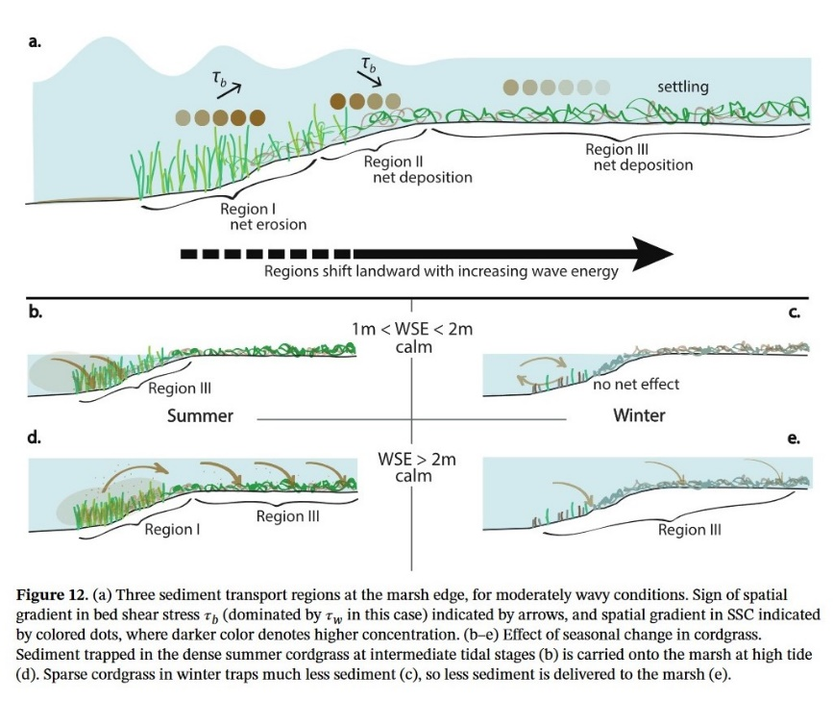

The measurements for data will be taken at the following zones, as outlined and demonstrated through this conceptual diagram (Lacy 2019):

* Region 1: (closest to the mudflats) Characterized by wave-driven resuspension, a  
  landward increase in bed shear stress and SSC, and net erosion.
* Region 2: Vegetation strongly attenuates waves, and bed shear stress and SSC  
  decrease in the landward direction.
* Region 3(within the pickleweed) is also depositional. Bed shear stress is spatially  
  uniform and particle settling is the dominant process.

#### Suspended Sediment Measurements

The following suspended sediment variables will be focused within the five field sites, as  
taken from the methodology of (Lacy 2019 and Thorne 2022)

* Surface Elevation Tables (SETs): Quantify net surface elevation change
* Feldspar marker horizons (MH): Quantify deposition or accretion above a clay  
  feldspar layer applied on the marsh surface.
* Short term suspended sediment concentrations using sipper bottles to capture a 24  
  hour time stamp at mean high high water (MHHW) tide mark, when it is known that  
  most of the sediment that later accretes in the upper reaches of the marsh are  
  transported

#### Vegetation Measurements

Within the five field sites, pickleweed will be mapped 30-50 meter between the pickleweed zone and the cordgrass zone (Lacy 2019) beyond the point of growth from the marsh edge, with the following measurements collected across 5 transects from each marsh edge site:

* Canopy density using imageJ to map out the amount of the picture is taken up
* Presence of annual vs perrenial pickleweed within the plot in each transect
* Canopy height (in field measurement)
* Branching pattern complexity (random sample from plot of 5-10 plants)

### Data Acquisition and Analysis

The following data points will be plotted across linear regression curves to understand the relationship between variables:

* Short Term Accretion Collection (SETs-Weight measurement-grams)
* Suspended Sediment Collection (Sipper bottles-Weight measurement-grams)
* Long Term Accretion Collection (MH-Change in length/height-centimeters)
* Vegetation Structure (% Density of the image, Highest Canopy height-cm, # of  
  Branches of average plant)

## Need for Research

## Understanding and comparing the way the sediment moves across the marsh edge, as well as the role of the vegetation in the accretion of sediment in marsh are interlinked knowledge points to understand the complexity of marsh function, and measure over time for marsh function and health. The work completed here could add new layers to understanding the complexity of the marsh, and compared to other measurements of the marsh that are commonly used to measure “health”, for example in annual shorebird counts and mammal monitoring. This work could also offer a new perspective on environmental monitoring of common living and nonliving parameters, such as tidal inundation as a mechanism for sediment transport, and vegetation surveys as a way to measure the functional physical components of an evolving marsh. Once we better understand the typical abiotic processes across the bayward side of the marshlands in terms of sediment transport, it will inform future decisions on managing unprecedented weather events.

## Relevance to State of California

As it stands, marsh ecosystems are already in a vulnerable position, with more than 90% of California wetlands drained, largely for human resource use (California Natural Resources Agency 2010). The potential damage to this limited resource of a marsh ecosystem cannot be overstated if local land managers cannot accurately anticipate and understand how to adapt their marshes overtime.

We have already seen the anthropogenic impacts on our sediment bank within the San Francisco Bay marshlands through the development of the “centennial marshland”, a subsection of the marsh built up entirely of the sediment eroded from the goldrush era’s numerous dynamite actions across the Sierra Nevada (Barnard 2013). These events show the impact of both small and cumulative actions across a landscape to change local habitats.

## References

Boorman, L. A., Garbutt, A., & Barratt, D. (1998). The role of vegetation in determining patterns of the accretion of salt marsh sediment. *Geological Society, London, Special Publications*, *139*(1), 389–399. https://doi.org/10.1144/GSL.SP.1998.139.01.29

Dunson, W. A., & Travis, J. (1994). Patterns in the Evolution of Physiological Specialization in Salt-Marsh Animals. *Estuaries*, *17*(1), 102. https://doi.org/10.2307/1352338

Fagherazzi, S. (2013). The ephemeral life of a salt marsh. *Geology*, *41*(8), 943–944. https://doi.org/10.1130/focus082013.1

Ganju, N. K., Schoellhamer, D. H., & Bergamaschi, B. A. (2005). Suspended sediment fluxes in a tidal wetland: Measurement, controlling factors, and error analysis. *Estuaries*, *28*(6), 812–822. https://doi.org/10.1007/BF02696011

Gedan, K. B., Silliman, B. R., & Bertness, M. D. (2009). Centuries of Human-Driven Change in Salt Marsh Ecosystems. *Annual Review of Marine Science*, *1*(1), 117–141. https://doi.org/10.1146/annurev.marine.010908.163930

Houttuijn Bloemendaal, L. J., FitzGerald, D. M., Hughes, Z. J., Novak, A. B., & Phippen, P. (2021). What controls marsh edge erosion? *Geomorphology*, *386*, 107745. https://doi.org/10.1016/j.geomorph.2021.107745

Kirwan, M. L., Walters, D. C., Reay, W. G., & Carr, J. A. (2016). Sea level driven marsh expansion in a coupled model of marsh erosion and migration. *Geophysical Research Letters*, *43*(9), 4366–4373. https://doi.org/10.1002/2016GL068507

Moffett, K. B., Robinson, D. A., & Gorelick, S. M. (2010). Relationship of Salt Marsh Vegetation Zonation to Spatial Patterns in Soil Moisture, Salinity, and Topography. *Ecosystems*, *13*(8), 1287–1302. https://doi.org/10.1007/s10021-010-9385-7

Möller, I. (2006). Quantifying saltmarsh vegetation and its effect on wave height dissipation: Results from a UK East coast saltmarsh. *Estuarine, Coastal and Shelf Science*, *69*(3–4), 337–351. https://doi.org/10.1016/j.ecss.2006.05.003

Möller, I., & Spencer, T. (2002). Wave dissipation over macro-tidal saltmarshes: Effects of marsh edge typology and vegetation change. *Journal of Coastal Research*, *36*, 506–521. https://doi.org/10.2112/1551-5036-36.sp1.506

Ritter, A. F., Wasson, K., Lonhart, S. I., Preisler, R. K., Woolfolk, A., Griffith, K. A., Connors, S., & Heiman, K. W. (2008). Ecological Signatures of Anthropogenically Altered Tidal Exchange in Estuarine Ecosystems. *Estuaries and Coasts*, *31*(3), 554–571. https://doi.org/10.1007/s12237-008-9044-9

Smolders, S., Plancke, Y., Ides, S., Meire, P., & Temmerman, S. (2015). Role of intertidal wetlands for tidal and storm tide attenuation along a confined estuary: A model study. *Natural Hazards and Earth System Sciences*, *15*(7), 1659–1675. https://doi.org/10.5194/nhess-15-1659-2015

Taylor-Burns, R., Lowrie, C., Tehranirad, B., Lowe, J., Erikson, L., Barnard, P. L., Reguero, B. G., & Beck, M. W. (2024). The value of marsh restoration for flood risk reduction in an urban estuary. *Scientific Reports*, *14*(1), 6856. https://doi.org/10.1038/s41598-024-57474-4

Taylor-Burns, R., Nederhoff, K., Lacy, J. R., & Barnard, P. L. (2023). The influence of vegetated marshes on wave transformation in sheltered estuaries. *Coastal Engineering*, *184*, 104346. https://doi.org/10.1016/j.coastaleng.2023.104346

Temmerman, S., Bouma, T. J., Govers, G., Wang, Z. B., De Vries, M. B., & Herman, P. M. J. (2005). Impact of vegetation on flow routing and sedimentation patterns: Three‐dimensional modeling for a tidal marsh. *Journal of Geophysical Research: Earth Surface*, *110*(F4), 2005JF000301. https://doi.org/10.1029/2005JF000301

Thorne, K., Jones, S., Freeman, C., Buffington, K., Janousek, C., & Guntenspergen, G. (2022). Atmospheric River Storm Flooding Influences Tidal Marsh Elevation Building Processes. *Journal of Geophysical Research: Biogeosciences*, *127*(3), e2021JG006592. https://doi.org/10.1029/2021JG006592

Thorne, K. M., Bristow, M. L., Rankin, L. L., Kovalenko, K. E., Neville, J. A., Freeman, C. M., & Guntenspergen, G. R. (2024). Understanding Marsh Elevation and Accretion Processes and Vulnerability to Rising Sea Levels Across Climatic and Geomorphic Gradients in California, USA. *Estuaries and Coasts*, *47*(7), 1972–1992. https://doi.org/10.1007/s12237-023-01298-4

Vandenbruwaene, W., Maris, T., Cox, T. J. S., Cahoon, D. R., Meire, P., & Temmerman, S. (2011). Sedimentation and response to sea-level rise of a restored marsh with reduced tidal exchange: Comparison with a natural tidal marsh. *Geomorphology*, *130*(3–4), 115–126. https://doi.org/10.1016/j.geomorph.2011.03.004

Vandenbruwaene, W., Schwarz, C., Bouma, T. J., Meire, P., & Temmerman, S. (2015). Landscape-scale flow patterns over a vegetated tidal marsh and an unvegetated tidal flat: Implications for the landform properties of the intertidal floodplain. *Geomorphology*, *231*, 40–52. https://doi.org/10.1016/j.geomorph.2014.11.020

## Budget and Justification

This field-heavy data collection requires extensive driving and bridge tolls.

In addition, conference attendance to share and compare findings is very pertitnent considering how location specific these findings are

| Item/Description | Unit Price | Quantity | Amount to Awardee (via Financial Aid) | Amount to Department |
| --- | --- | --- | --- | --- |
| Bridge toll(s) | $9.25 per bridge trip | 6 months | $1,688.13 | N/A |
| Gas, 2 full tanks per month | $138.30/2 full tanks | 6 months | $829.80 | N/A |
| Conference Attendance | ~$500/trip | 2 trips | $1000 | N/A |
| Conference | ~$241/trip | 2 trips | 482.07 | N/A |

## 

## Timeline

*December 2024-February 2025:* Collect preliminary data at and around the five study sites of interest, placing the short and long term accretion field methods out on the site and collecting within appropriate time limits.

*March-May 2025:* Analysis of winter results, planning for summer deployment of field instruments, and plan out tidal cycle timing for field collections

*June-August 2025:* Collect data at five study sites of interest including short and long term accretion field methods, suspended sediment monitoring, and canopy and density measurements of pickleweed on marsh platform.

*September 2025-November 2025:* Analysis of summer results, planning for winter deployment of field instruments, and plan out tidal cycle timing for field collections

*December 2025-February 2026:* Collect data at five study sites of interest including short and long term accretion field methods, suspended sediment monitoring, and canopy and density measurements of pickleweed on marsh platform.

*March-May 2025:* Analysis of winter results, planning for summer deployment of field instruments, and plan out tidal cycle timing for field collections. Begin to write up winter results and finalize.

*June-August 2025:* Collect data at five study sites of interest including short and long term accretion field methods, suspended sediment monitoring, and canopy and density measurements of pickleweed on marsh platform.

*September 2025-November 2025:* Analysis of summer results, begin write-up of final results.

*November 2025-February 2025:* Thesis write-up, prepare for defense